Improve your Bridge - a How to

Compiled by Roger Pfister http://RogerPf.com/aaBridge roger@RogerPf.com
You are an intermediate player and you want to improve. I'll bet you have done lots of studying and many courses. I will also lay odds that you know lots of "rules".
Such as: Lead 4th highest of your longest and strongest, particularly against no trumps.
Give, "attitude" on partners lead and "count" on declarer's & dummy's lead.
Don't get me wrong, these are good rules. But now what you need to do is to bring it all together. Your knowledge of Bridge is like a jigsaw puzzle you have dozens and dozens of pieces and few of them fit together to form a whole or even parts of the whole.
I promise you that when they do start to fit together, bridge becomes a lot easier.
With these rules, comes a tendency to think of Bridge (the play of the hand) is a succession of twelve decisions each one being "which card should I play now". To answer that question you naturally reach for the most appropriate "rule". This is not a good way to improve your bridge.
Let me break it to you now. To improve you have to let go of these rules and take a different approach.
The approach I advocate here is to stop asking yourself the question "Which card should I play next ?" and instead ask yourself the question – What is going on ?

The Loser Trap
Beware the loser trap. What I suggest later in this document is that you start to play differently. This will mean that you get different results. And to start with those results will tend to be worse than you used to get. If you think about it the world has to be this way.
If it wasn't, it would mean that whatever skill you had you could improve it by making small changes. This would mean that everybody would be able to slowly improve until we all became expert at everything, sport, business and anything else you care to add to the list.
The world is not like that. When you make changes you get worse before you get better. The expectation is that your new ways and your old ways will merge and the longer term result will be that you are playing better. The loser trap is where people do not allow this process to play out and instead when they discover they are now worse they make more changes, and guess what they get even worse.
In summary, what I am saying is, if you give these changes a try, you need to give them a serious try.

Defensive Play Only ?
While at first sight it may appear that this is all about defensive card play. It really isn't. At all stages in a bridge hand, bidding, declarer play and defensive play. You should be asking yourself the question – What is going on ?
It is perfectly true that when you are the declarer the main thing that should be "going on" is you putting your plan into action to make your contract. But that is no reason not to keep your eye open for the signals that the defenders (good defenders) will give each other.
<continued on next page>

What is Going On ?
So the core advice comes down to this. When it is you turn to make a decision. Bidding and Play (and particularly in defensive play).
STOP, don't reach for your rules.
DON'T think to yourself. What is the correct card to lead / play ?
Instead think to yourself. What is going on ?

I know this WILL BE hard. But the only way to improve is to do things differently. And the only way to get a even the vaguest idea of what might be a better play is to start to think about what is happening on THIS deal. YES the one you are playing at THAT MOMENT.

Example
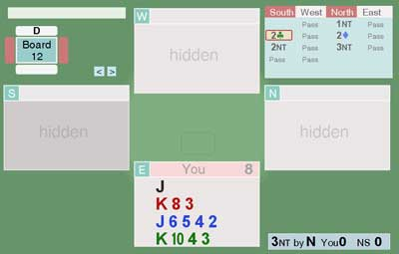
Here is an example hand from a deal I played in two days ago.
You are on lead. North your RHO had opened a 15-17 NT and the 2 clubs is alerted as Stayman.
The book lead, the "I don't have to think lead" is the 4 of Diamonds.
But wait a moment. That is not how I am telling you to play. Before having any thoughts of about what to play – THINK . . .
What is going on ?
I know, it is not easy, but What is going on ? Well South (your LHO) has bid Stayman and that shows a max of 4 Spades / 4 Hearts. Did you say to your self as LHO bid 2 clubs. "4S/4H max". Probably not.
Next RHO has responded 2 Diamonds saying no 4 card Major here. Hmm so this means that the most LHO can have is 4 Spades and the most N can have is 3 Spades so partner (remember partner) MUST have at least 5 Spades. Why because 4 + 3 + 1 (your Jack) = 8. And if North (RHO) only has 2 spades then partner must have 6.
So I could be very helpful to partner if you lead your singleton Jack of Spades.

<continued on next page>

What is going on ? Partner's view.
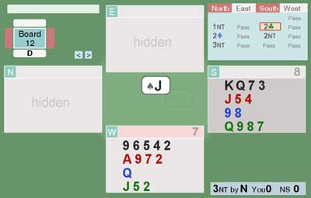
What thoughts does partner get to have when she sees the Jack of Spades.
She has see the same bidding. She can see the four spades that South (her RHO) has promised and she knows that North (1 NT opener) must have at least 2 Spades.
So partner knows the Jack is either singleton or at best doubleton. And it certainly won't be lead Jack from the Ace, Jack.
So partner can put North (her LHO) with the Ace of spades and quite likely he may even have the 10.
Now partner knows what is going on in Spades.
Partner can file away in her mind that declarer has a likely 4 top tricks in Spades and there is no point whatsoever in returning "your" suit. That is one rule she won't have to think about this deal.
I suppose you are going to ask – Which card should partner actually play ?
Whatever cards declarer / dummy plays it will then be obvious to you (sitting opposite) that when partner fails to play the Ace, North must have it. So your partner is now free to give a signal. The normal rules of signalling are that.
If attitude is known or obvious then give count, unless count is known then give suit preference.
In this case she will know that you don't know whether she has five or six spades. So she would play the 2 of Spades showing an old number, which we both know in this case is 5.

It is not that you don't use the rules that you have learnt. The point is you need to delay using them until after you have spent your energy thinking about the answer to the question, What is going on ?

Did the Jack of Spades turn out to be some devastatingly brilliant lead ? No it did not. But possibly not leading a diamond helped to side track declarer as he later misplayed the diamonds and went down in a contract he should have made.

<continued on next page>

So what sort of things count as good input to the question - What is going on ?
An Opp opens 1 of a major - assume they have 5.
An Opp opens 1 club - assume they have 3. They rebid two clubs put them with 5.
An Opp opens 1 diamond - assume they have 4.
An Opp bids 2 clubs Stayman - assume they have at least one 4 card major.
An Opp opens 2 of a major - assume they have 6.
An Opp opens one of a suit put them with 11 to 15 points. They make a stronger bid, increase this.
I am sure you can add to this list

One Suggestion to get a Solid Benefit from Minimal Counting
By the end of the bidding and particularly after the first lead has been made you should know roughly how many points declarer and dummy combined have started with. Make the small effort to add their points to yours and take the number away from 40.
This will give you a rough guide as to how many points partner has started with this will often be a low number such as 6 to 7. Whenever during the play of the hand partner plays an honour subtract that card from the number of points you know he has left.
Later in the play this will really help when you come to ask yourself questions like; could partner have the missing King of Hearts ?

In Her Shoes
One approach that can be helpful is to notice how declarer goes about playing the hand. Then while looking at dummy ask yourself the question.
If I was playing the hand this way, what suit lengths and high cards would I be likely to have ?
If dummy has a good suit that is being left alone this might imply declarer has the missing honours and she is planning to run it later. The question in your mind should be – why hasn't declarer tried to set up that suit. In this case a possible answer is – because it doesn't need setting up.
And if that is the case, it means that, maybe when your side gets in, you had better be caching your winners.

Switching is hard
I do understand that stopping yourself from instantly thinking - Which card should I play ? and starting to think – What is going on ? – is hard.
You need a trusting partner who understands, and hopefully is trying to do exactly the same thing, remembering that, as the loser trap predicts, when you start to make changes you will always get worse. Your ever trusting partner needs to understand this will happen (in the short term).

<continued on next page>

If Only there was a Way to Practice at an Unhurried Pace - There Is
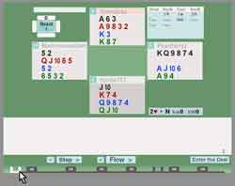
There is a high end version of the procedure I am going to describe, which is already documented in aaBridge. It is part of the aaBridge Document Collection. The file is called Defend like an Expert - a How to
What I'm going to describe next can be seen as Defend like an Expert - LITE

In aaBridge menubar > Books > (pick any year) > (left hand column - pick any Week)
2013 is a good year to start with. You have opened one of the Hondo mentoring sessions.
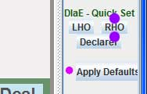
Now you need to set up aaBridge to play the deals in a way that will not let you see what you should NOT see.
Click on the RHO button – marked with purple dots.
When you have completely finished all this, Please click the Apply Defaults button to put every thing back to normal – notice the REAL pink dot.

Entering the Deal
If you have a mouse or track pad with a right button then you can Right Click on the first major bobble
on the Navbar. In the image above these are labelled o2 o3 o4 o5 etc. If you do not have a right button OR you forget to use it just click on the Enter the Deal button as quickly as you can. The idea is to get you into the deal WITH OUT you SEEING ANYING except you own cards. If you do see too much then just move to the next deal e.g. o3 and Enter that one.
DO NOT use the new 1st or Cont buttons which may be visible, please ignore them.
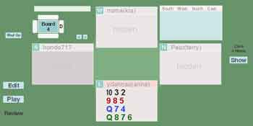
You should now see something like the diagram on the right. The important things are;
a) that you are in the South Zone (whatever your compass direction)
b) that you cannot see any hand except your own
c) that there should be no bidding visible.

<continued on next page>

The bottom bar will now be as show below

Click once on the single forward arrow (purple bots) and from then on switch to using you mouse wheel if you have one.

As you move forward first the bidding will be displayed bid by bid and then the first lead. Partner will always be on lead because you asked to always be declarers RHO.

After that will come the rest of the play.

So here is a friendly environment where you can practice thinking at an unhurried pace.

I know this advice will sound strange. But please at first do not try to play your hand.

The idea is that you spend all your energy asking yourself the question – What is going on ?

If you are trying to "get the count". That means if you are trying to work out what declares original distribution was in terms of how many cards in each suit, and you get lost. You can always wind back to the beginning of the play and start again.

My suggestion is that as soon as you find yourself not bothering to ask the question What is going on ?

Then leave it alone and come back another day when you are less tired.

I absolutely promise you that if you put effort into this your will bridge will improve.

Oh yes and best you don't forget. . .

Apply Defaults

When you are finished please click the Apply Defaults button to put every thing back to normal (marked by the REAL pink dot.)

<end of document>

